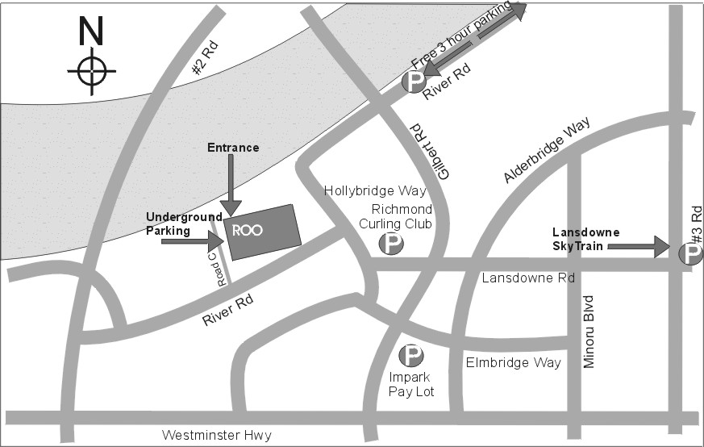
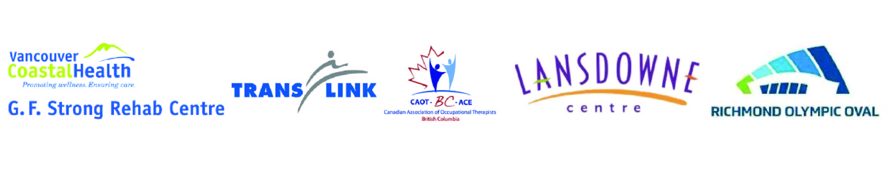
Tuesday Sep 10th 2019 8am - 4pm
Richmond Olympic Oval 6111 River Rd,
Richmond, BC, V7C 0A2

Free Parking and Free Shuttle Service
Park at Lansdowne Mall (Sky Train Station)
Shuttle to and from REE every 10 - 15 mins.
Starts - 7am Ends - 5pm
A limited amount of pay parking is available at the Oval.

Admission $2
(Car poolers, cyclists and transit users free)

Complimentary food and drinks
(including a bag lunch - 11.30 to 1pm)

EDUCATION SCHEDULE

WHAT THE MEPP? 10:00 to 10:30am

In this presentation Jill Longhurst (PT) and Kevin Waldorf (OT they will provide a review of the new provincial Medical Equipment Provision Program (MEPP), including participating vendors (the Canadian Red Cross as primary vendor and seven additional vendors across the province) how to refer clients, and answers to frequently asked questions.

WEIGHT BIAS AND IMPACT ON HEALTH EQUITY Noon to 1:00pm
Dr. Mary Forhan will provide strategies to provide quality care that considers bariatric care needs of clients living with obesity.
POWER ASSIST FOR MANUAL CHAIRS 2:30pm to 3:00pm

Dr. Jaimie Borisoff will provide a brief overview of different attachable power-assist devices for manual wheelchairs. They will demonstrate front-, rear-, and pushrim-activated power assist products and review the performance characteristics of each device category.

FREE ADMISSION
If this form is presented at the registration desk already filled in:
We are trying to speed things up at registration - so if it isn’t filled in (legibly)you have to pay $2.

--------------------------------------------------------------------------------------------------------------------------------------------------

Name____________________________________ Email ____________________________________

